Social Media Project :

Steps:

1 > create project ‘SocialMedia’ and then create app ‘mainApp’ inside that project.

2> creating ‘templates’ and ‘static’ folders in main project’s directory.

3> adding ‘templates’ and ‘static’ in settings.py file’s appropriate place.

4> creating index.html and setting url and view for it.

5> adding whatever needed for index.html

6> now creating custom user to use email as primary key and not username in User.

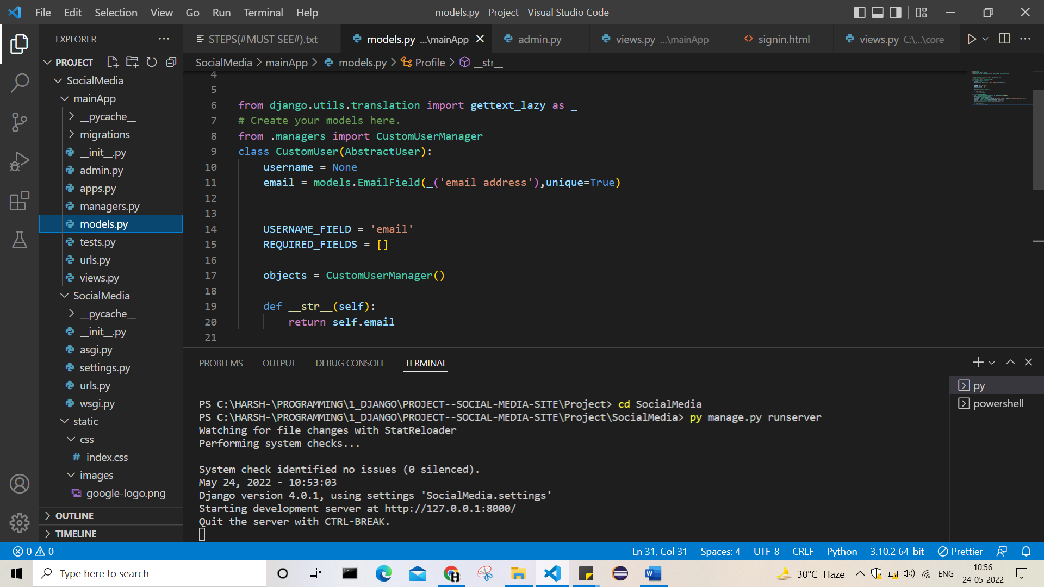

7> creating manager for this custom user.

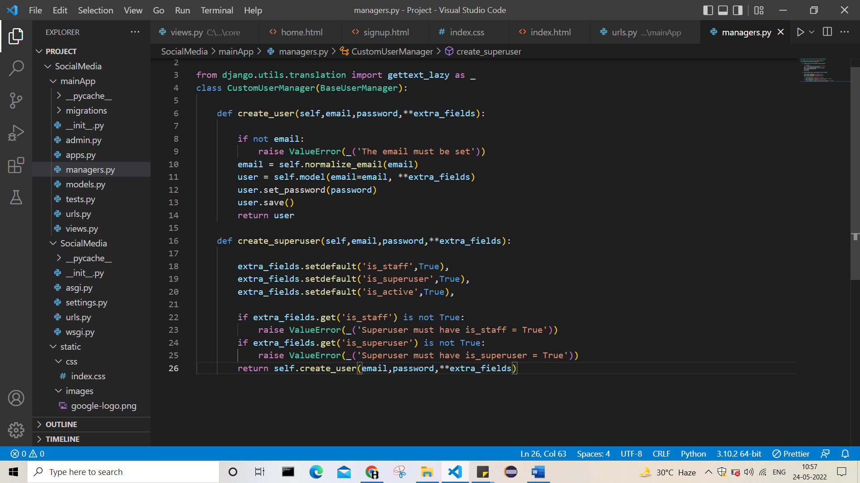

Now 2 methods , one for simple user and another for super user.

For super user using extra fields need to set flags of permissions.

8> registering custom user in admin.py

9> setting AUTH_USER_MODEL = mainApp.CustomUser

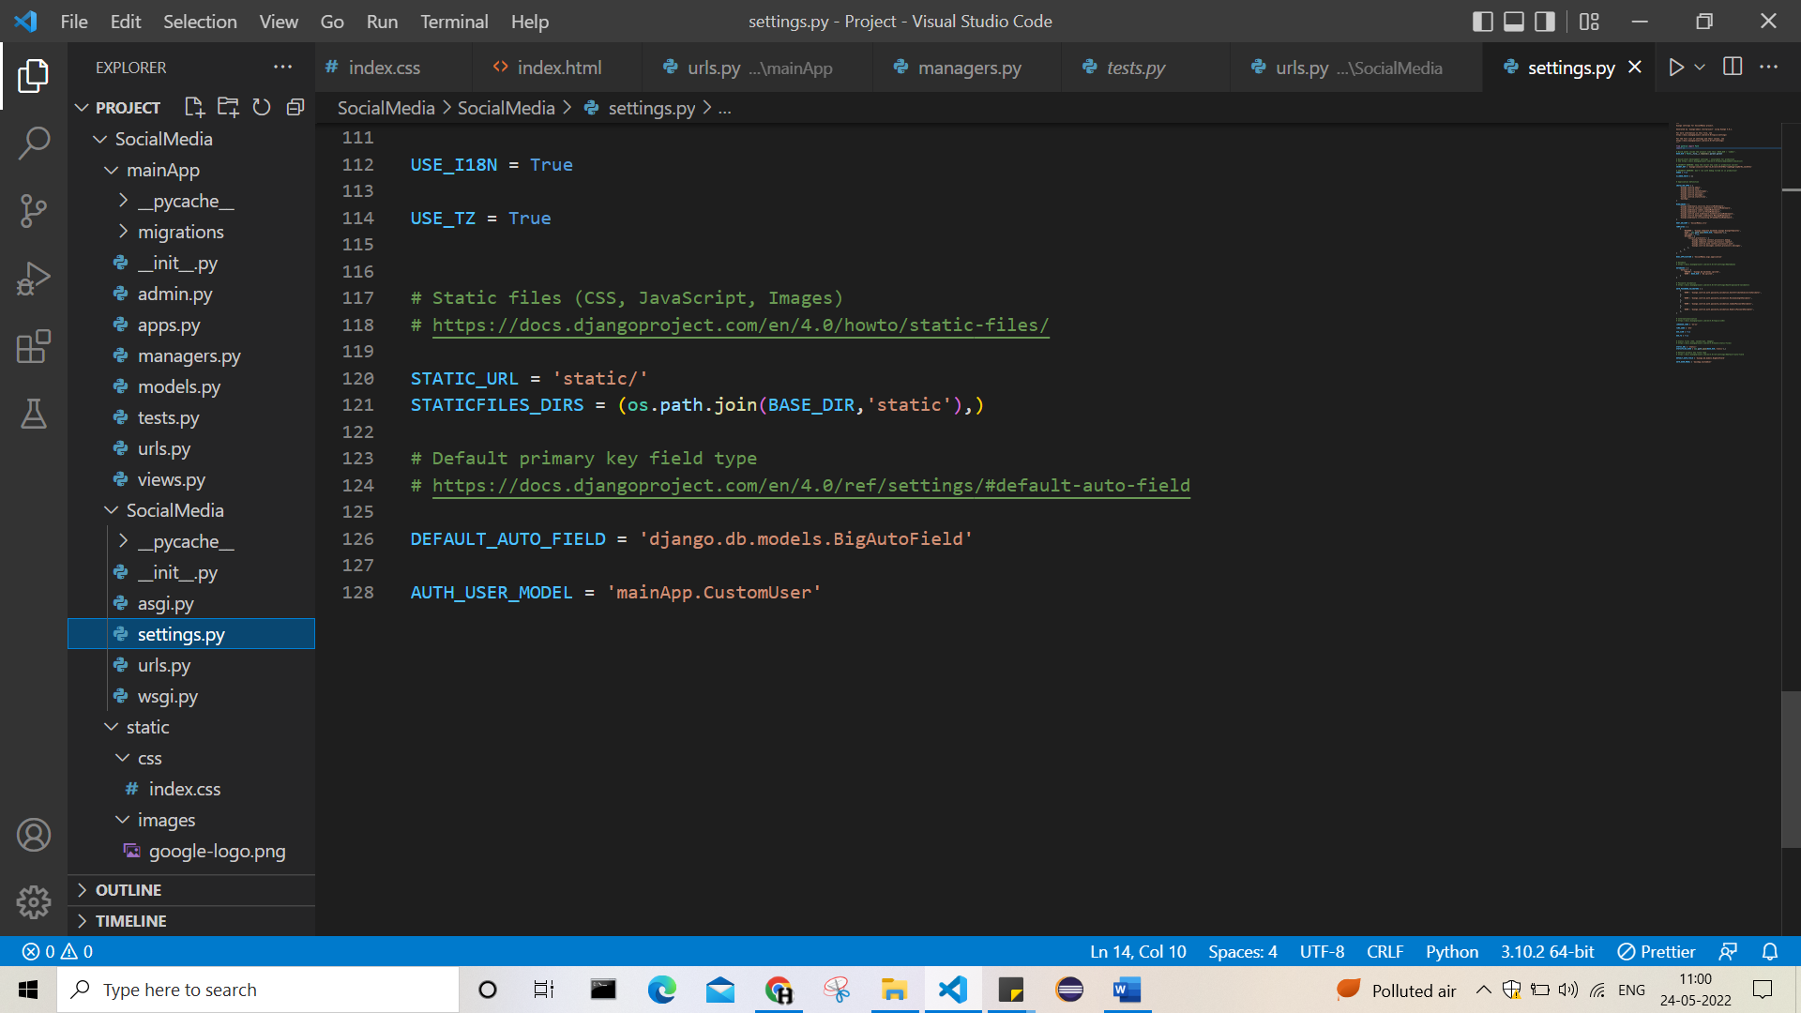

To use customUser as main.

10> now creating superuser from command line

And there we can clearly see the difference created using custom user.

Now email and password be the 2 fieldsat starting of user, by default it was username and password.

But by changing to custom user, we have made it as we wanted.

11>now after this moment, whatever user is created we are going to create it using create_user.

Cz those are normal user, not super ones.

12> now setting pages inde.html, signup.html

13> now checkout this pic:

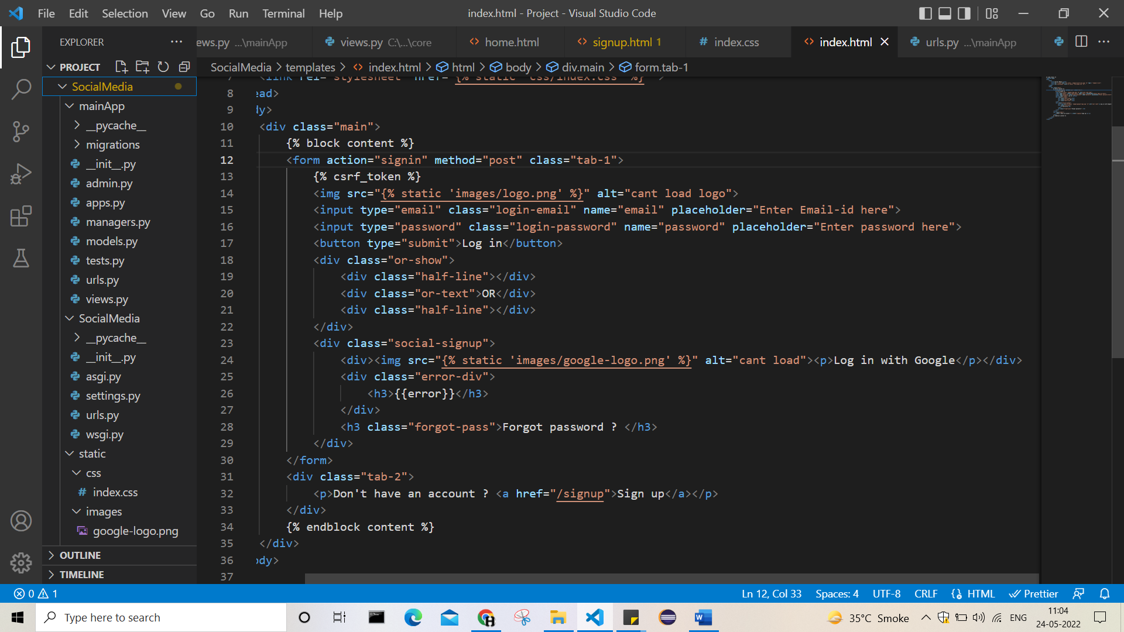

Here as we can see, as we click on signup we will be giving Django the url: /signup

So it goes to it’s url.py and find appropriate view for it.

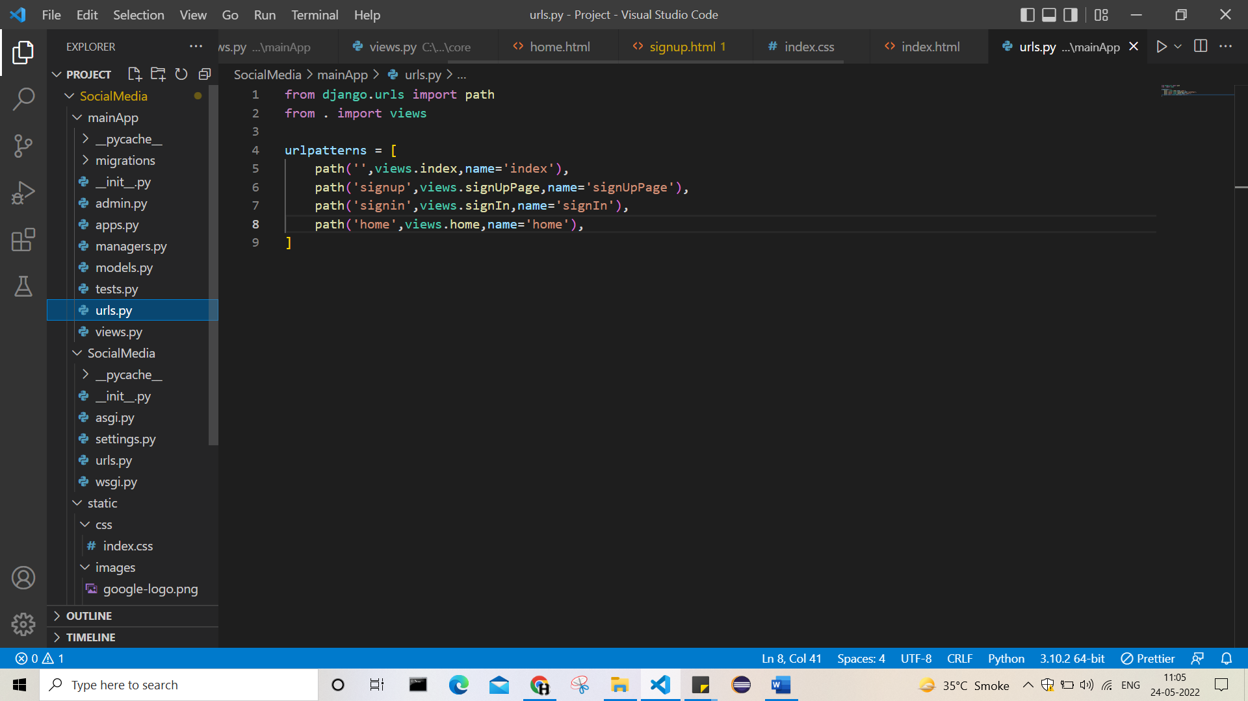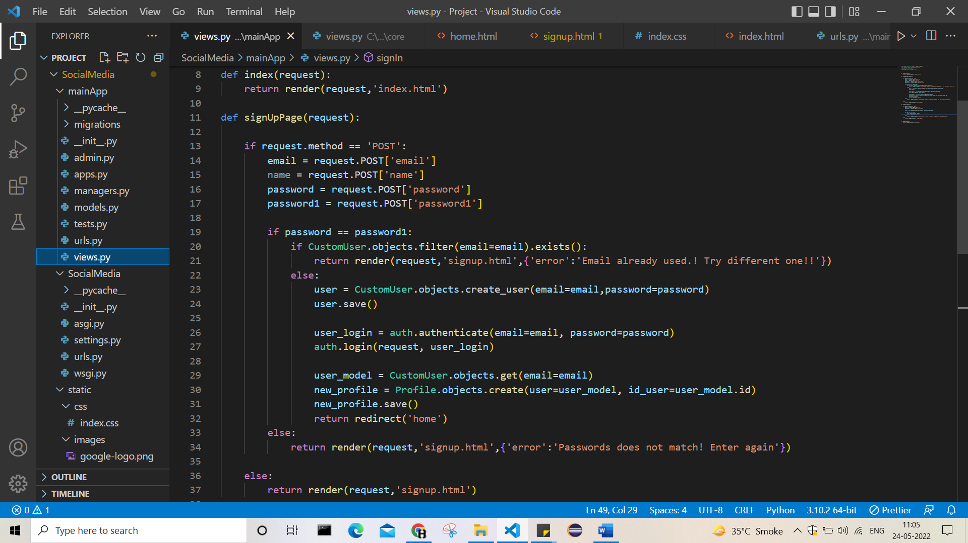

So this the sugnup page view:

Now here:

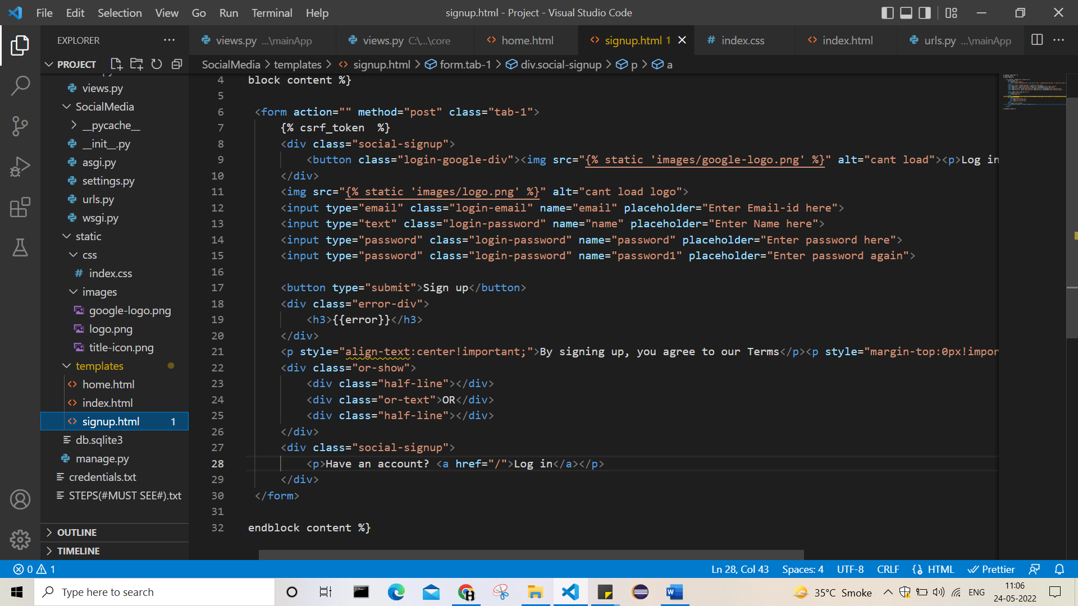

Lookout the signup page shown above here, we have submitted form without passing ‘action’

Means form goes to signup url itself.

So at first when we wanted the signuppage at that time we have not requested anything so if cond. Get false and we get our signup page only.

Now from that signup page we are submitting form without mentioning any action so again goes to signup now at this time method=post is passed so if condition becomes true and we goes under functionality.

Now as we can see from view, if any kind of problem then returned to page index.html itself.

Now if everything is fine, the we create user using create_user method, as we wanted normal user.

Then making login of it and redirecting to the home.html page.

14>

Now see this:

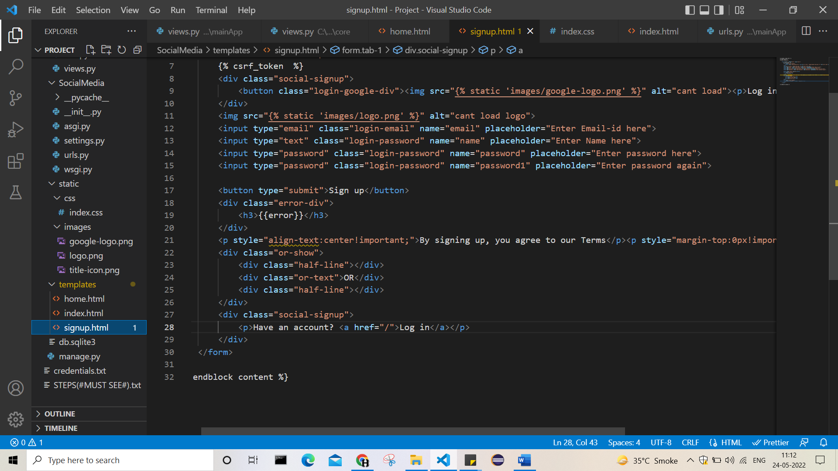

On clicking on login, we are redirected to index.html page as it contain login form.

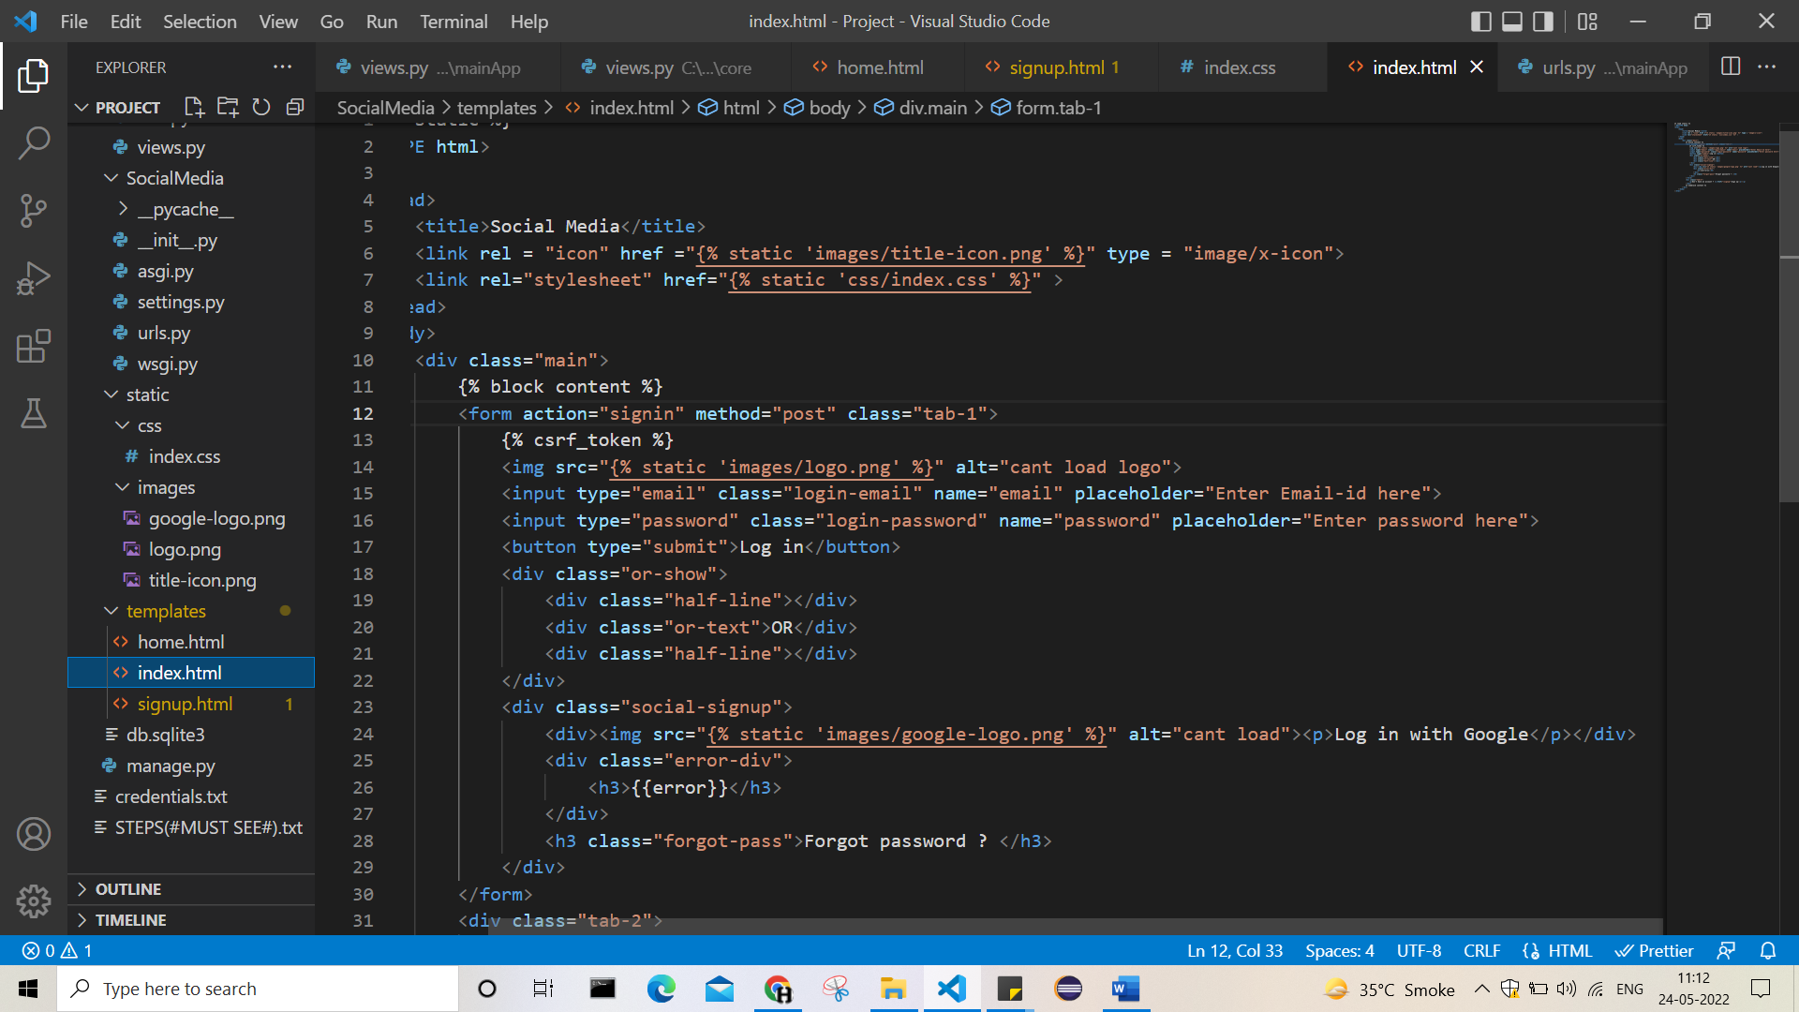

Now checkout the form, when we submit the form , action=signin is called.

So in urls.py appropriate view will be exceuted.

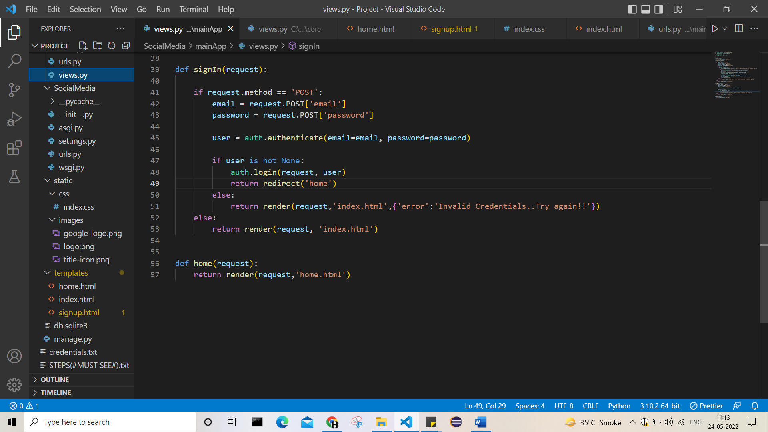

Now this is the view for signin.

It has also same logic, if not requested for login via passing, method then just rendering page as it is needed for intial steps.

Now if actual login process is needed then called signin from form

The we have method so if cond. becomes true:

And functionality called.

So if any error the rendered to index.html itself with error msg.

If everything is fine then using auth.login we are loging in the user and redirecting it to home page.

15> now created home page template and settings page template

16> setting names for fields In settings page

17> as we are uploading image or file then we need to user enctype=’multipart/form-data’

Otherwise gives error

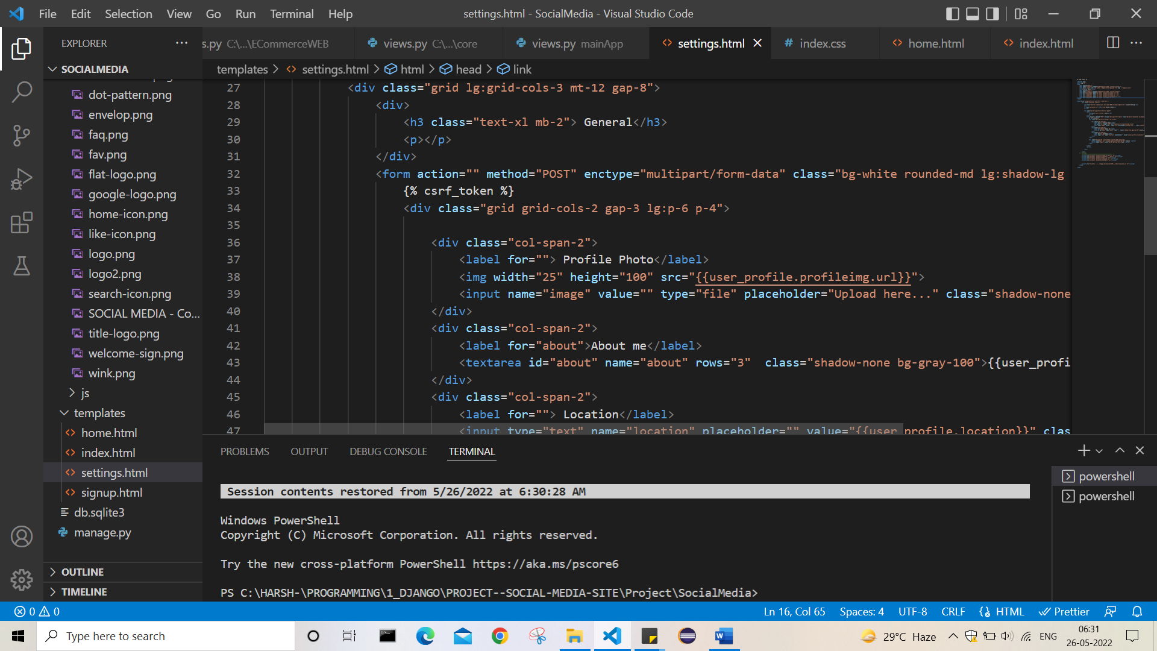

18> now taking all data and submitting form

19> as not action mentioned it goes to view of itself.

As post method sogo in if cond.

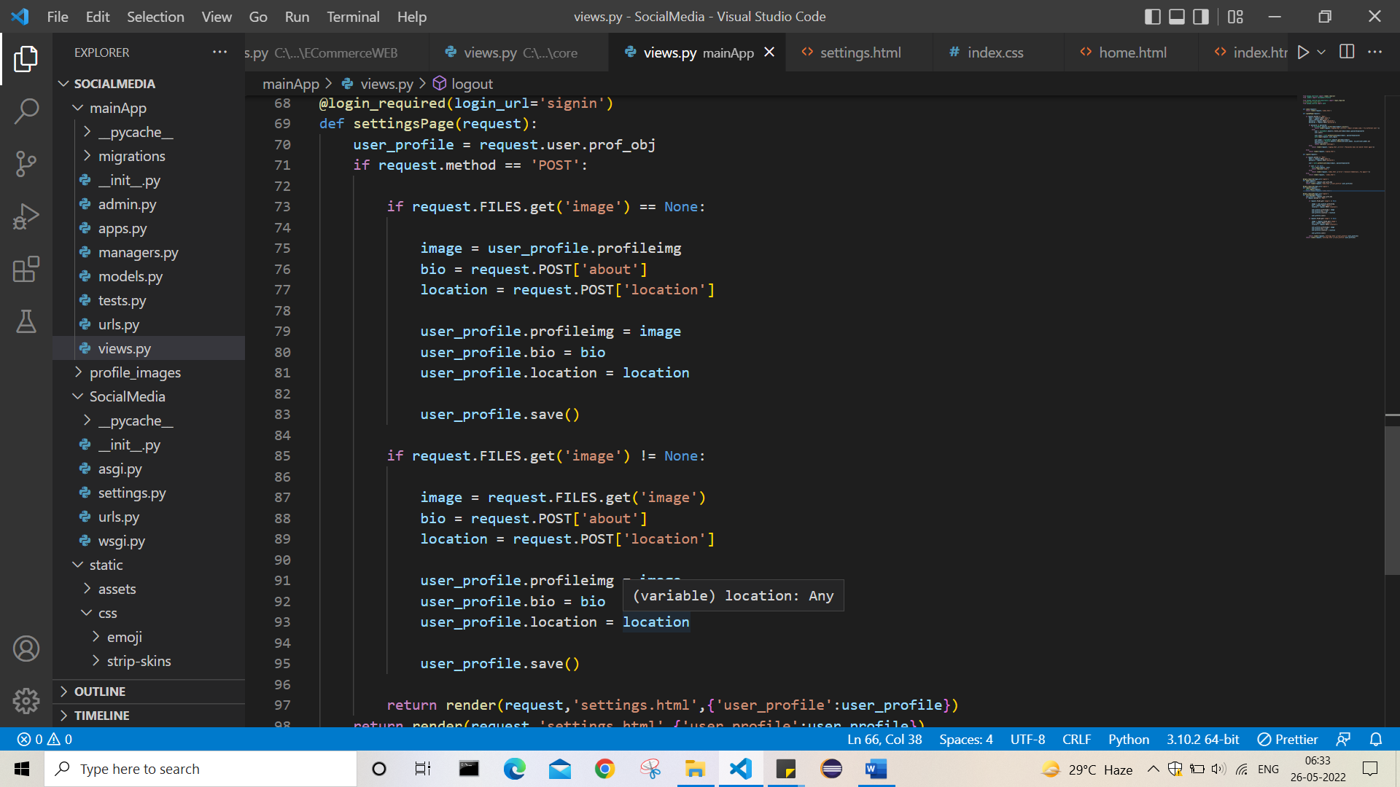

Where checking if file is uploaded or not

Then returning back to settings page where we can re edit or go back to home

19 >

At home, in header setting userprofile img and also css for give options on hover

Now 2 opt. are there, settings and logout

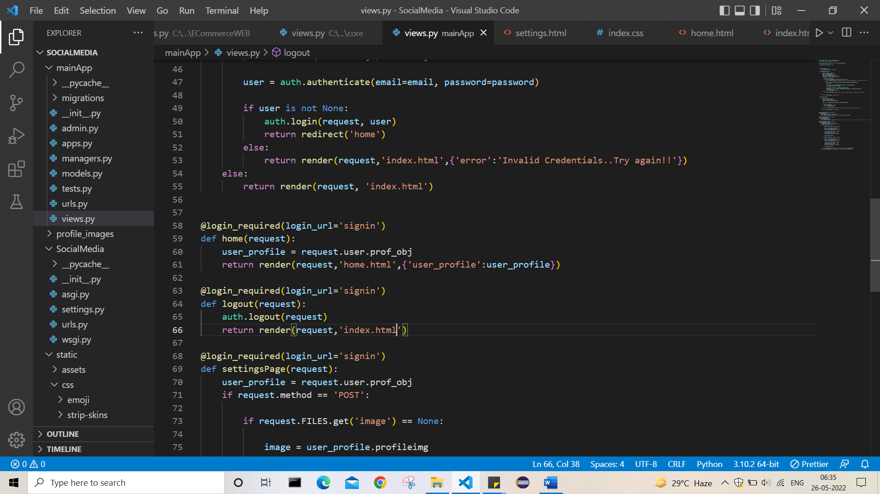

In both links added which leads to respective task.

After loging out rendering index page

20> now creating post class :

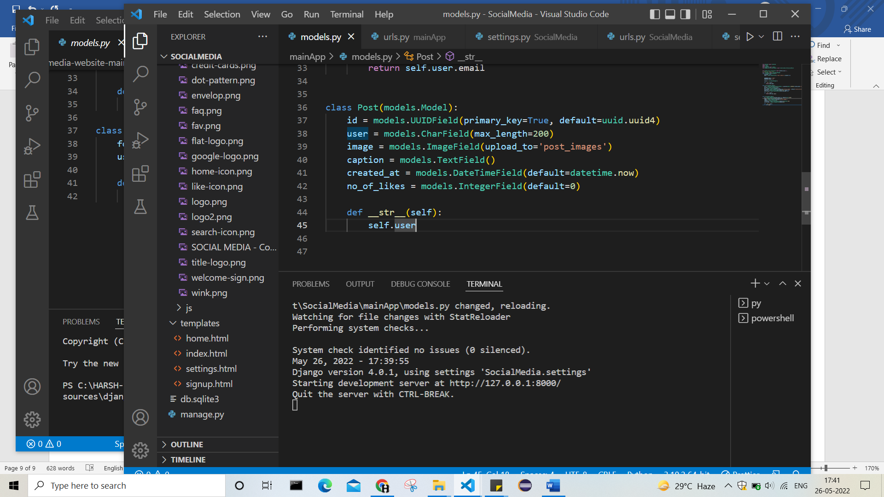

Here id = UUIDField(pk = True, default = uuid.uuid4) means:

For this need to import uuid

This uuid generates unique id’s

Making it as primary key – that’s id for this particular post

21> now creating containers for upload post functionality.

22> adding upload pic func. In html page

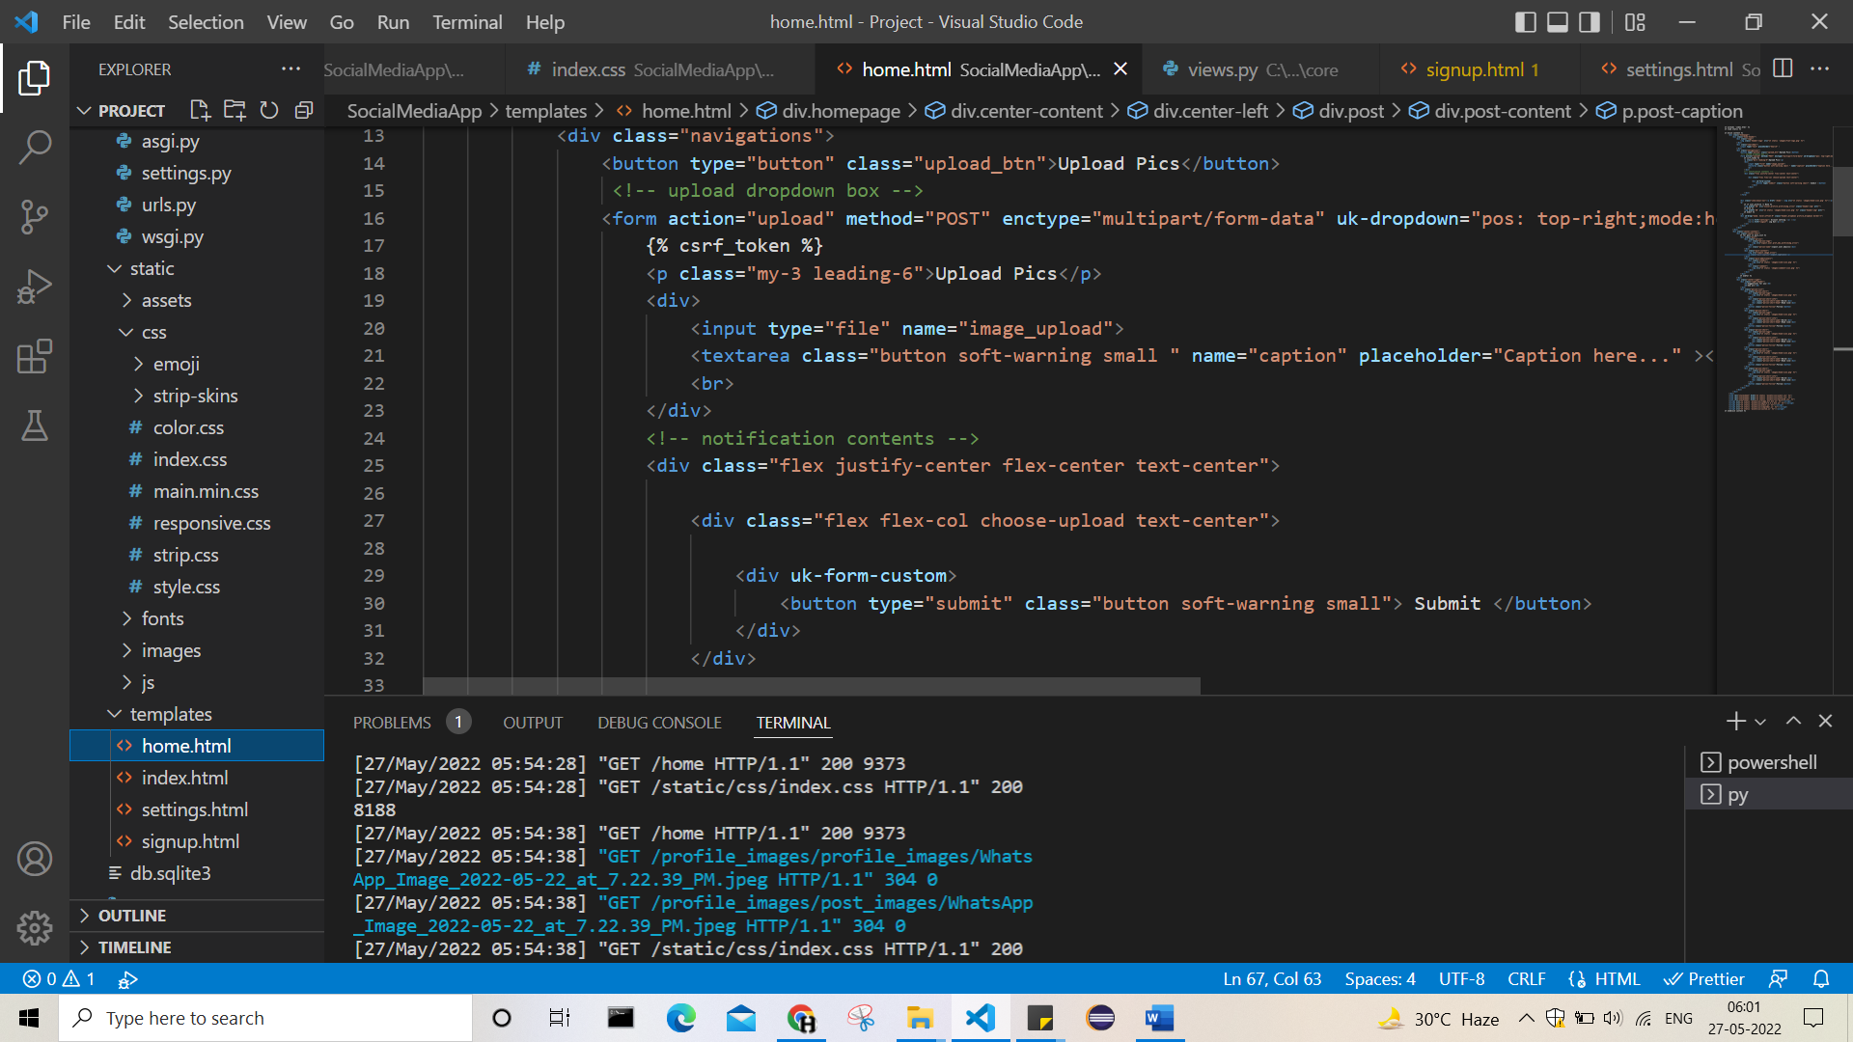

23> Now creating url and view for upload

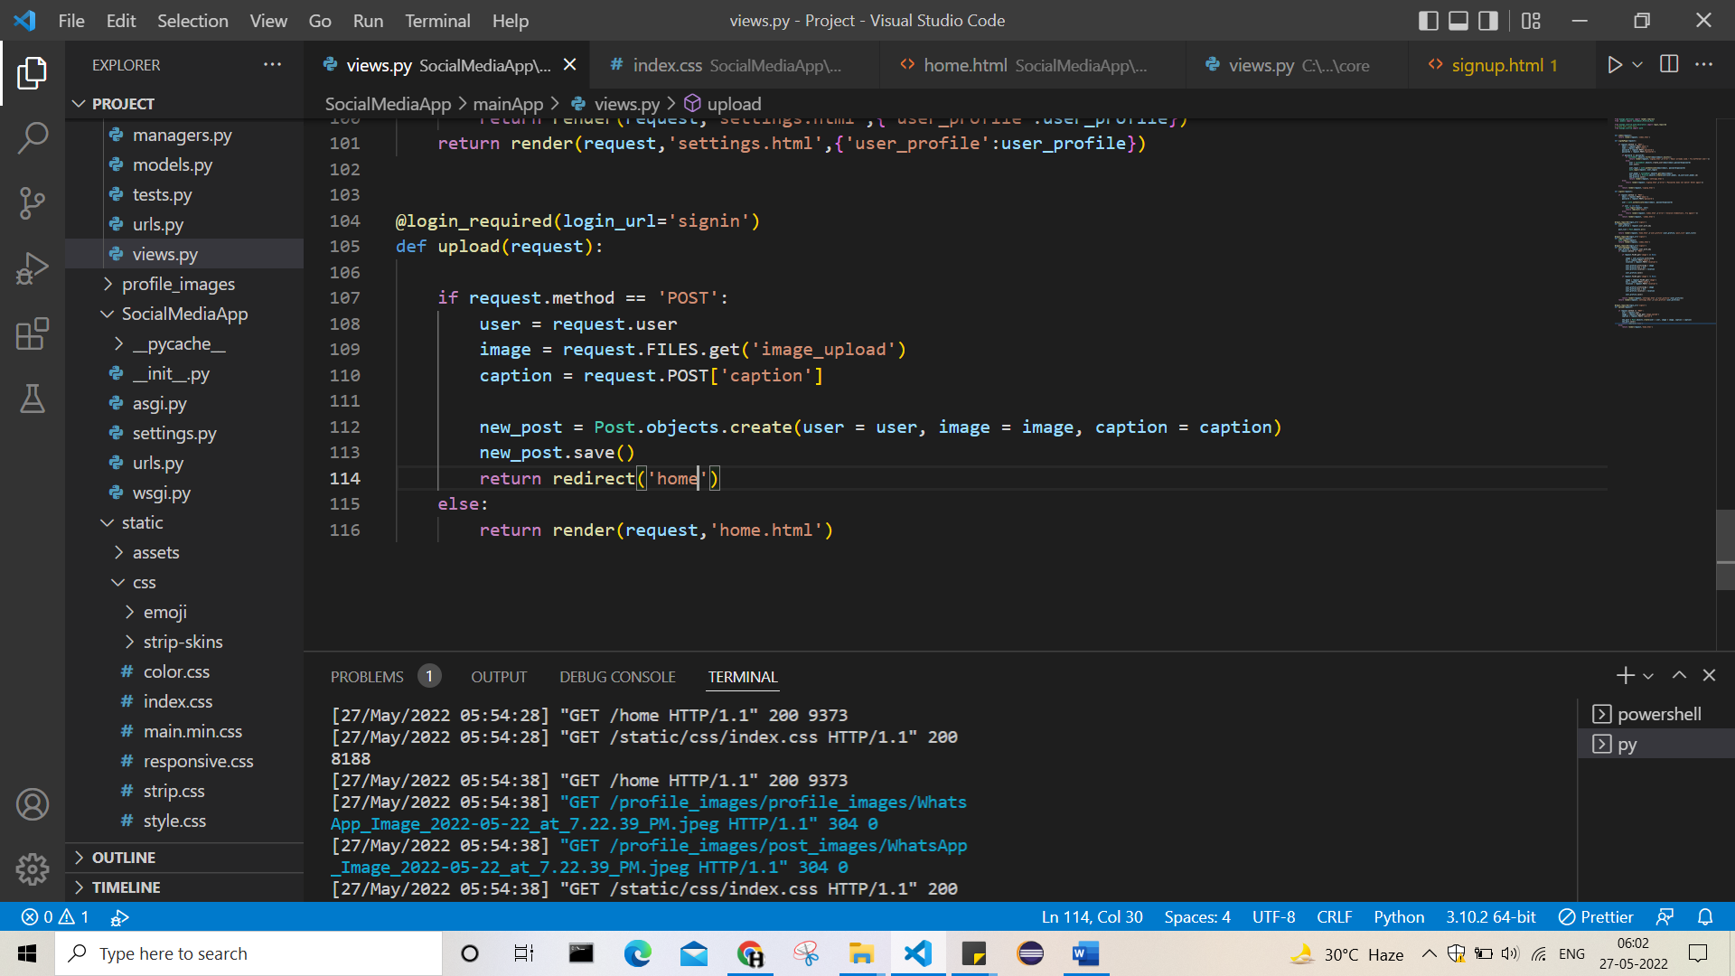

24>As upload successful redirecting to home page and there making post feed

Setting post_list in home view to show all posts In feed.

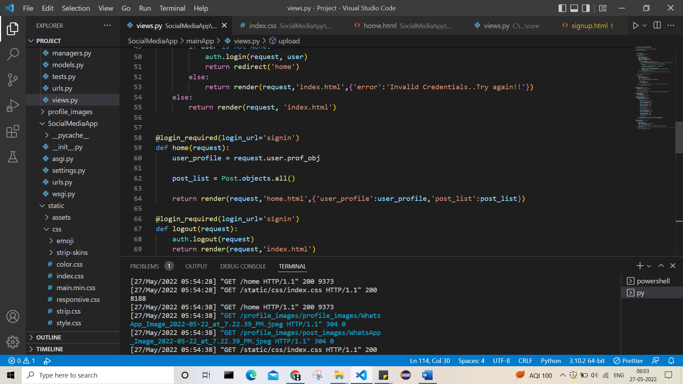

25> setting place to feed all posts in home page

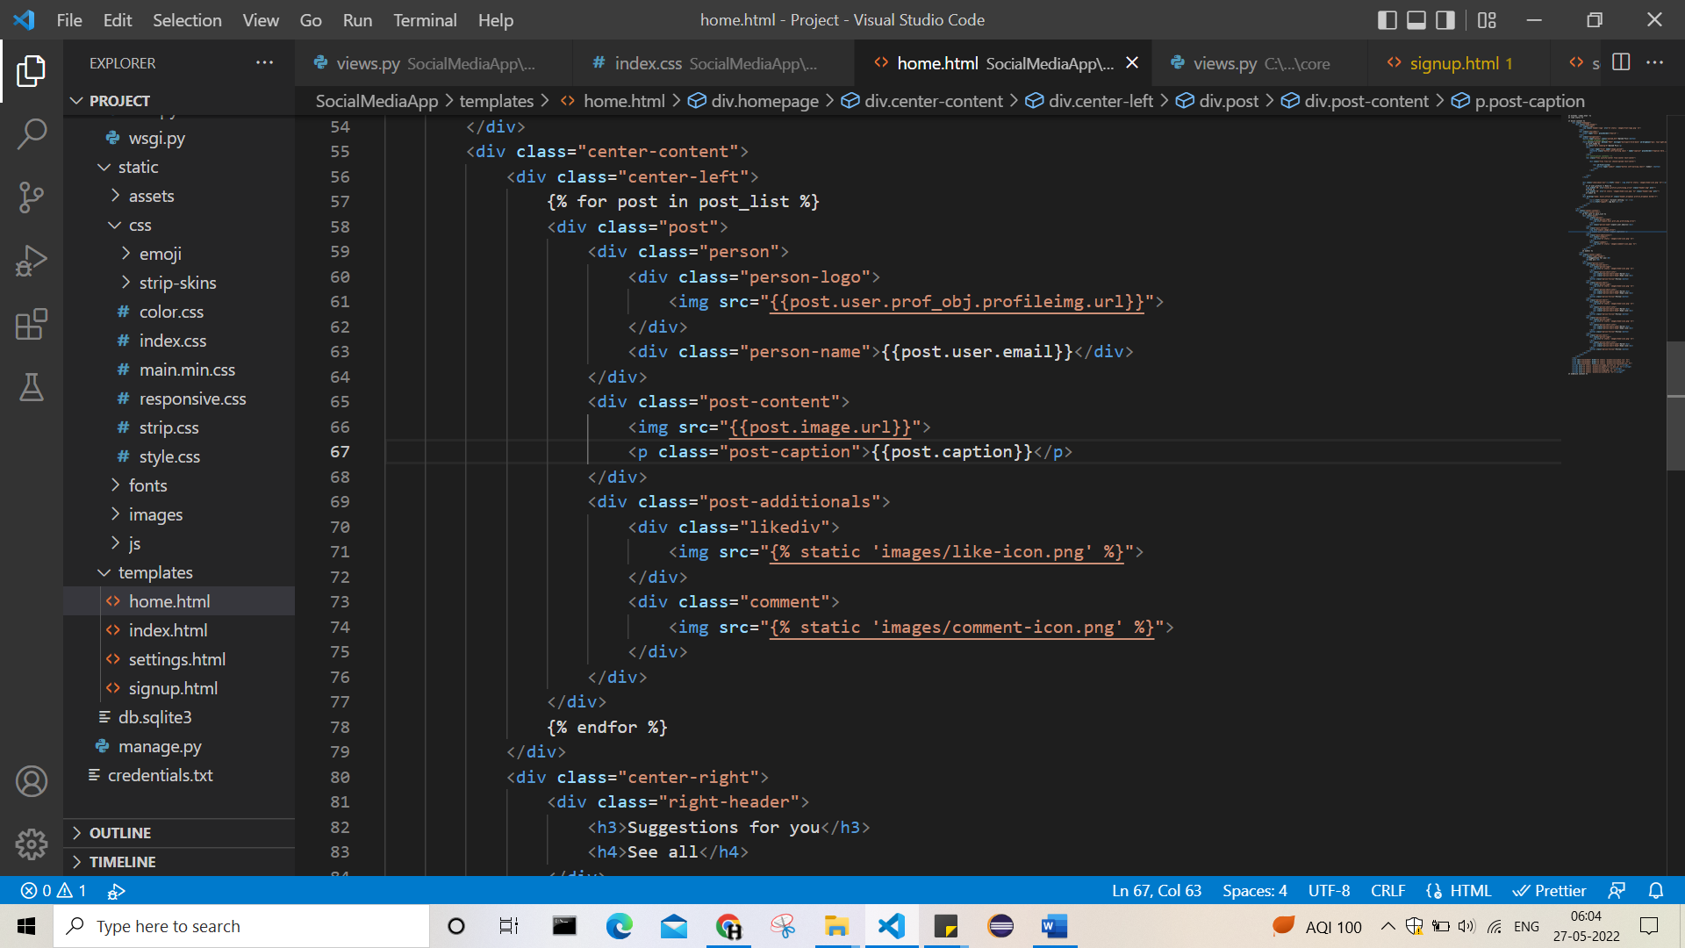

Now post section completed.

27> creating follower class, contains following_to and followed_by.

And making appropriate views.

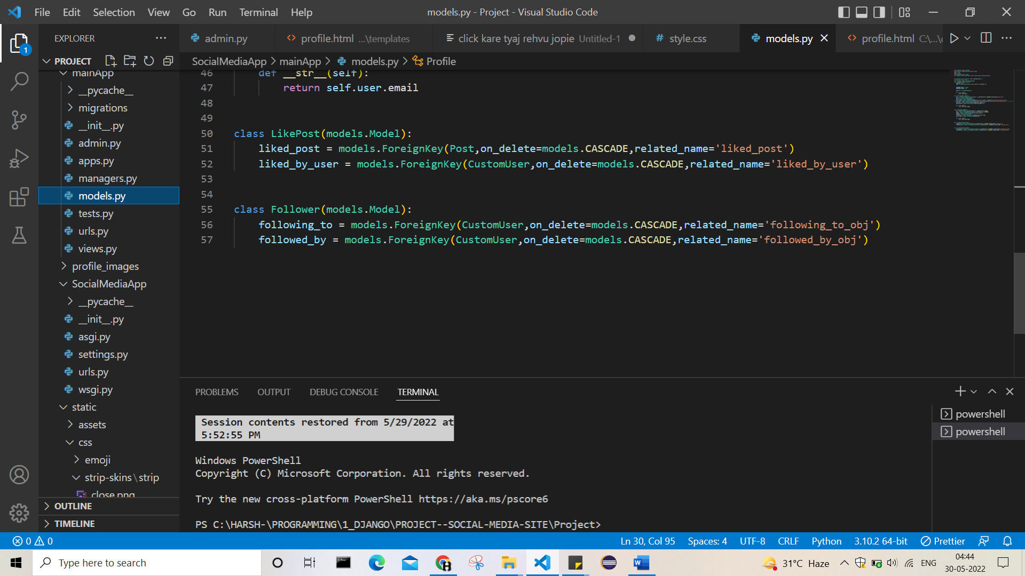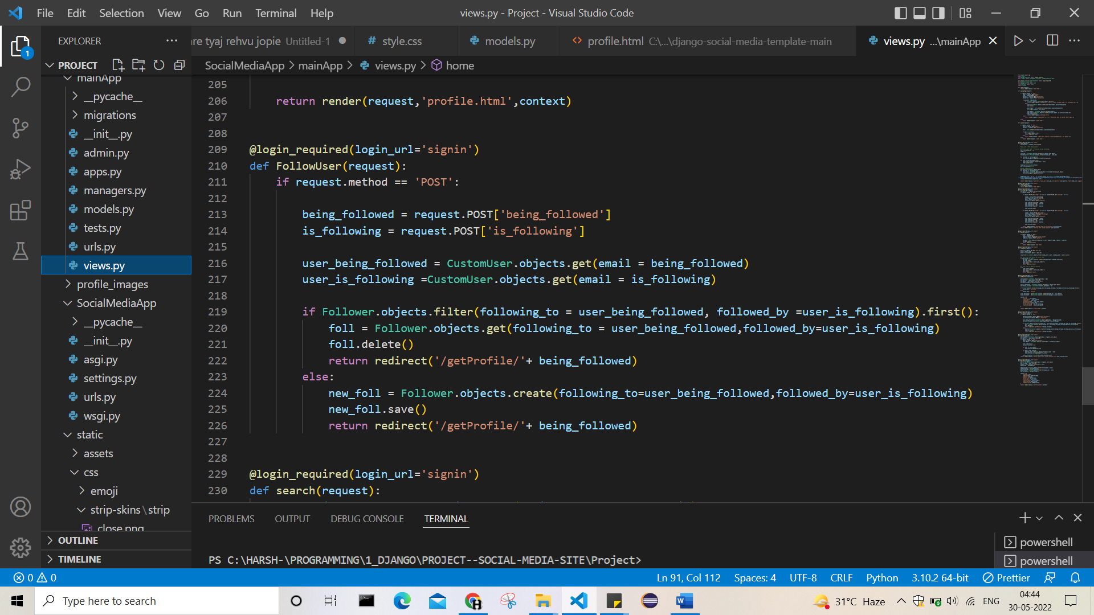

28> making user’s getProfile

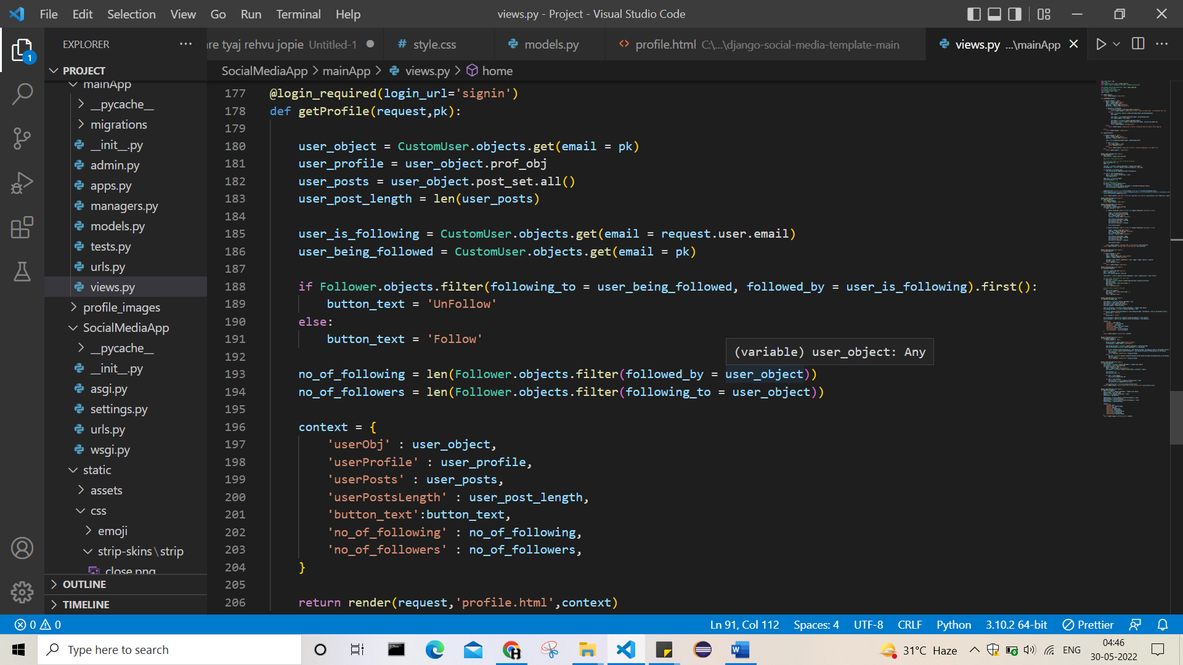

29> and making changes in htmls as appropriate

30> making like func.

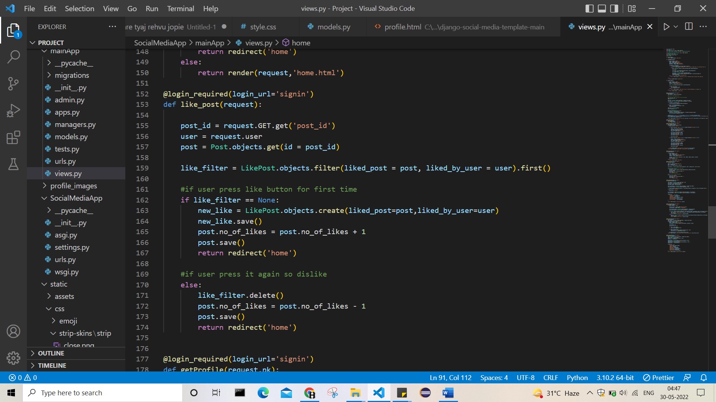

31> making my profile

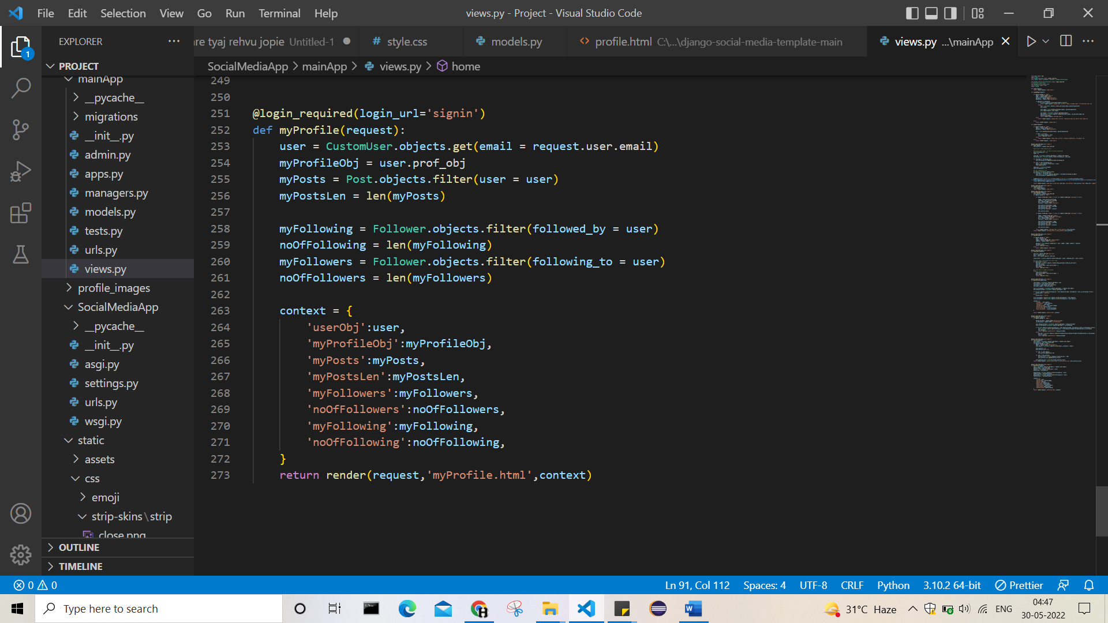

\32> making search func.

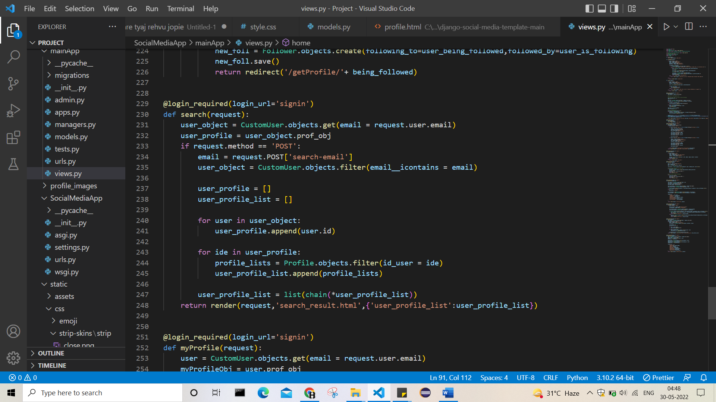

33> above things made, sequence. May be different but done.

34> delete post for user

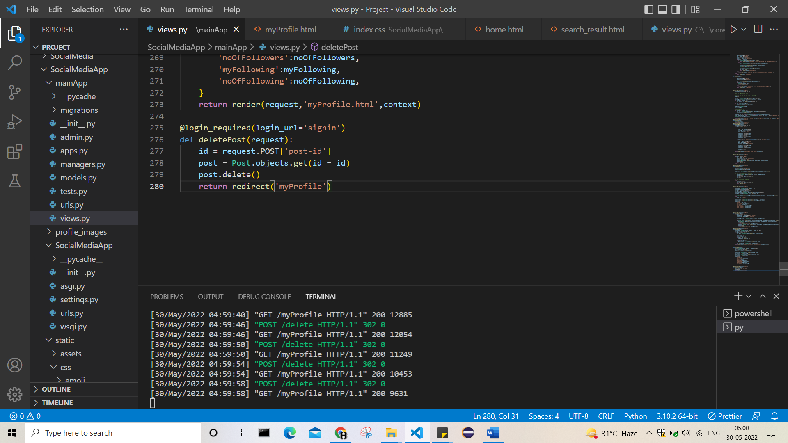

35> setting func. Like if zero post then shows no posts.

36> UPDATED FEED.-> shows only feeds of which we have followed.

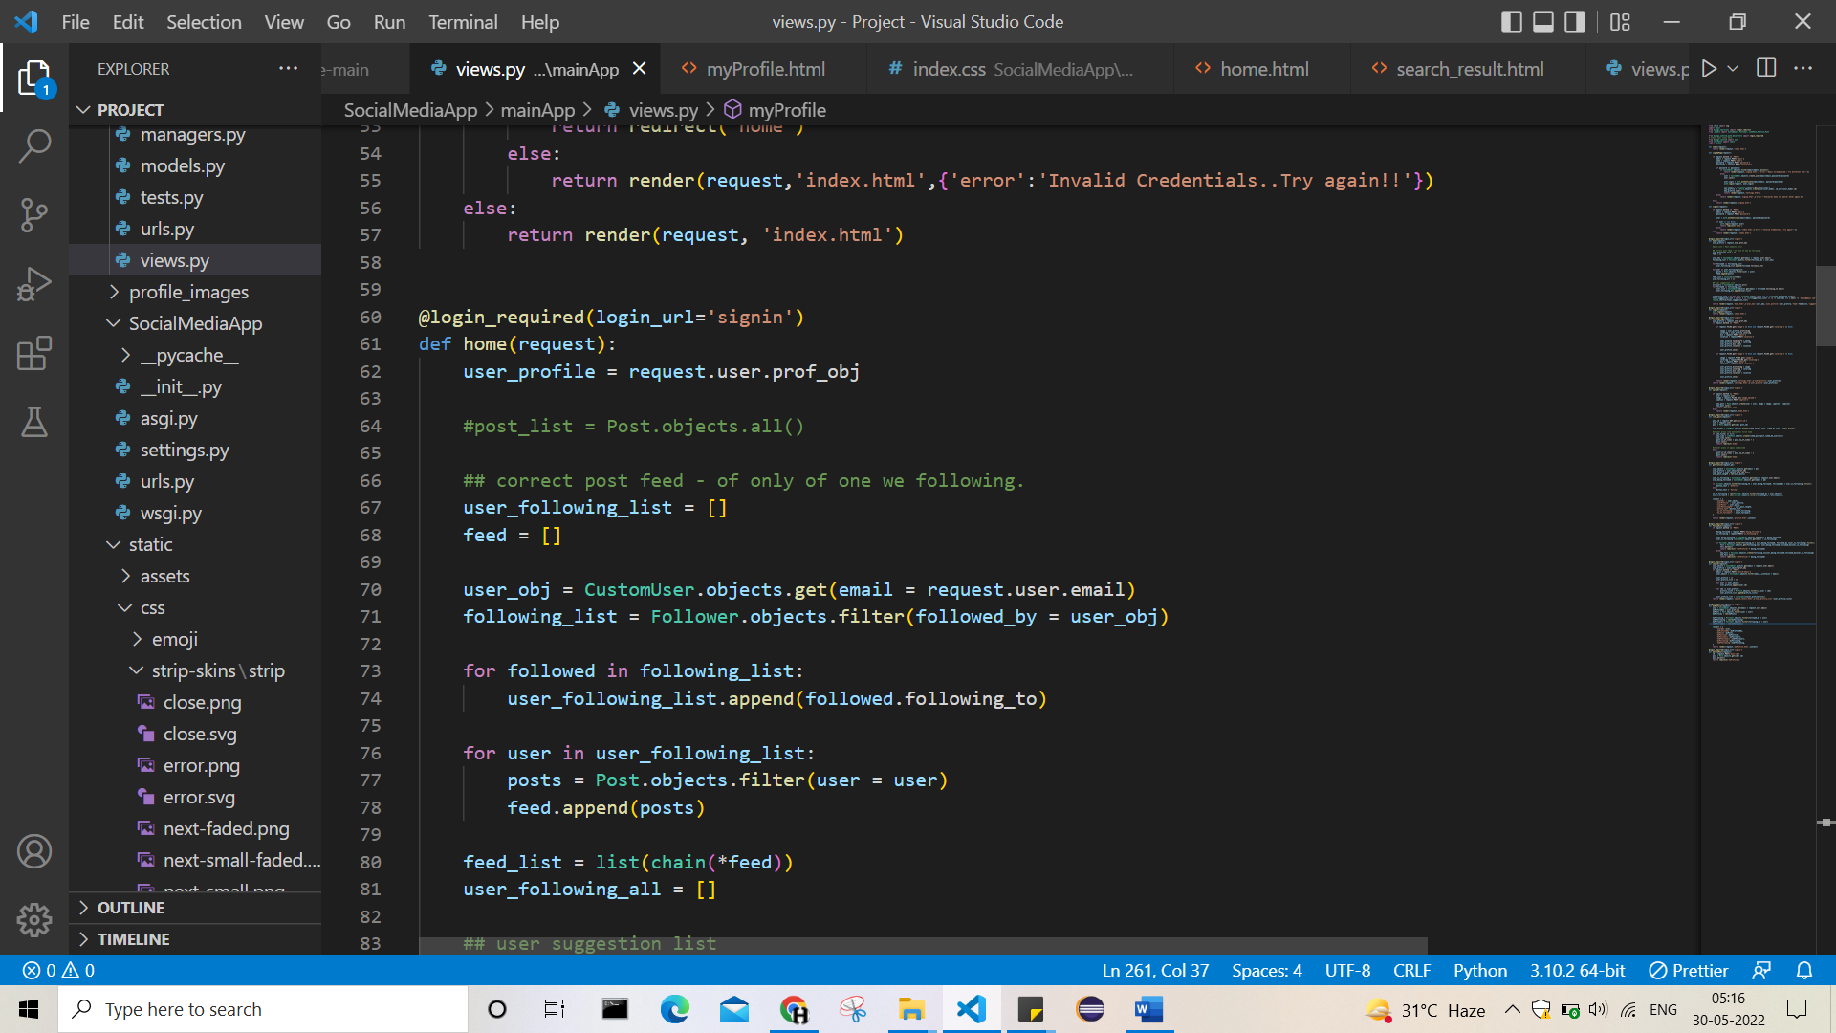

37> making suggestion user func.

And cancel out the admin and the user which we already follow

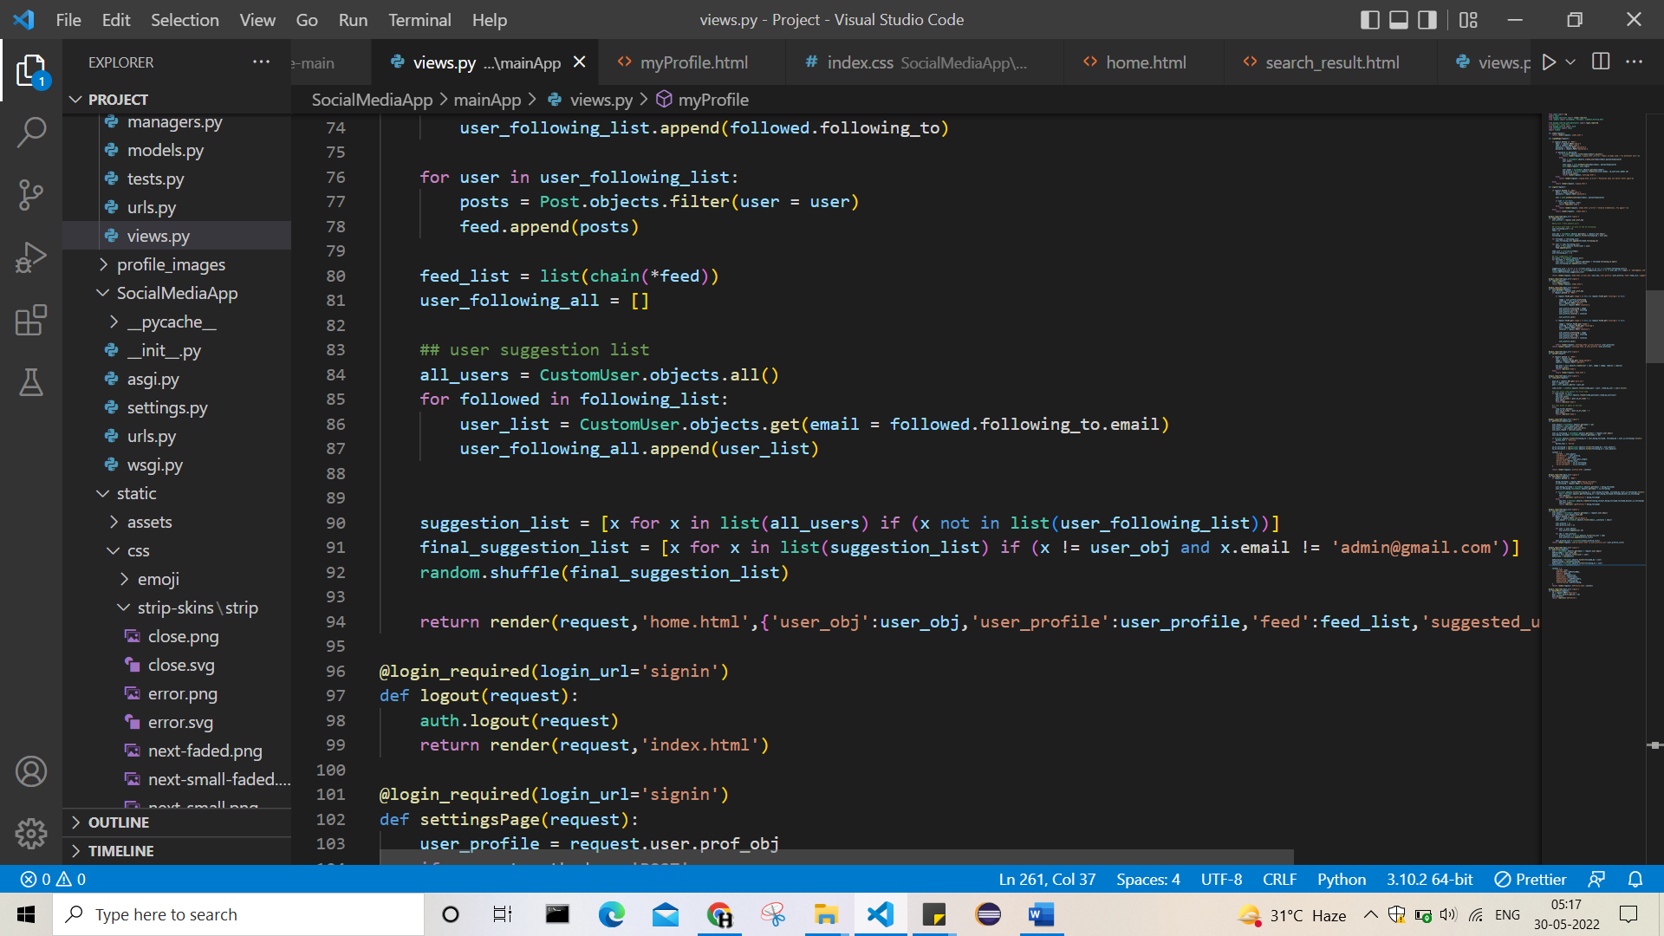

38> at initial, when no following,follower then no feed on home so showing text

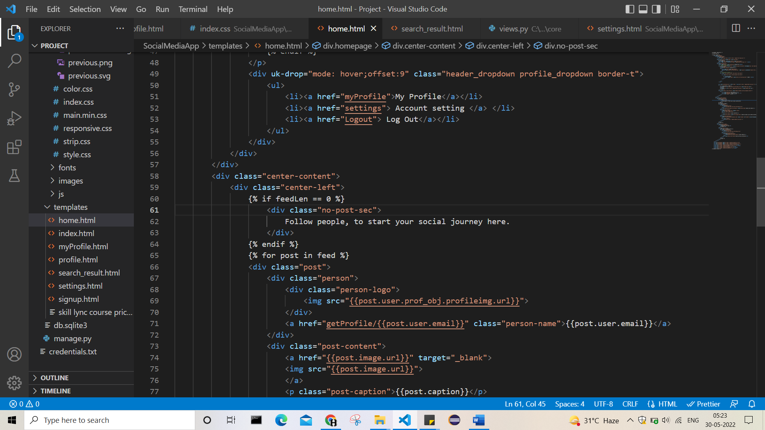

39> adding field username in profile, and showing it on display instead of email

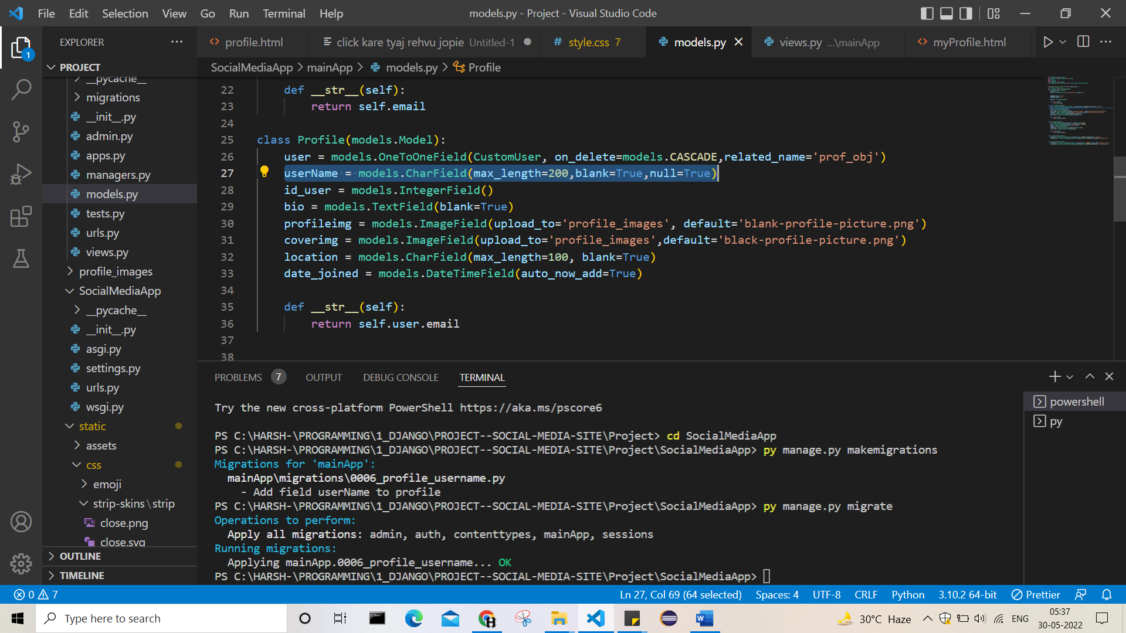

40> closing for now,

Add next: like btn thing, comment, share,

->when we like some post then, the page is reloading so going on top,

But actualyy it need to be at that place only, so check that.